**VISVESVARAYA TECHNOLOGICAL UNIVERSITY**

**“JnanaSangama”, Belgaum -590014, Karnataka.**



**LAB REPORT**

**on**

**Machine Learning**

***Submitted by***

**Neha Cathrin A (1BM19CS099)**

***in partial fulfillment for the award of the degree of***

**BACHELOR OF ENGINEERING**

***in***

**COMPUTER SCIENCE AND ENGINEERING**



**B.M.S. COLLEGE OF ENGINEERING**

**(Autonomous Institution under VTU)**

**BENGALURU-560019**

**May-2022 to July-2022**

**B. M. S. College of Engineering,**

**Bull Temple Road, Bangalore 560019**

(Affiliated To Visvesvaraya Technological University, Belgaum)

**Department of Computer Science and Engineering**



**CERTIFICATE**

This is to certify that the Lab work entitled “**Machine Learning**” carried out by **Neha Cathrin (1BM19CS099),** who is bonafide student of **B. M. S. College of Engineering.** It is in partial fulfillment for the award of **Bachelor of Engineering in Computer Science and Engineering** of the Visvesvaraya Technological University, Belgaum during the year 2022. The Lab report has been approved as it satisfies the academic requirements in respect of a **Machine Learning- (20CS6PCMAL)** work prescribed for the said degree.

**Dr G R Asha** **Dr. Jyothi S Nayak**

Assistant Professor Professor and Head

Department of CSE Department of CSE

BMSCE, Bengaluru BMSCE, Bengaluru

`

**Index Sheet**

|  |  |  |
| --- | --- | --- |
| **Sl. No.** | **Experiment Title** | **Page No.** |
| **1** | **Find S** |  |
| **2** | **Candidate Elimination** |  |
| **3** | **Decision Tree** |  |
| **4** | **Naïve Bayes** |  |
| **5** | **Linear Regression** |  |
|  |  |  |
|  |  |  |
|  |  |  |
|  |  |  |
|  |  |  |
|  |  |  |
|  |  |  |
|  |  |  |
|  |  |  |
|  |  |  |

**1.Implement and demonstrate the FIND-S algorithm for finding the most specific hypothesis based on a given set of training data samples**

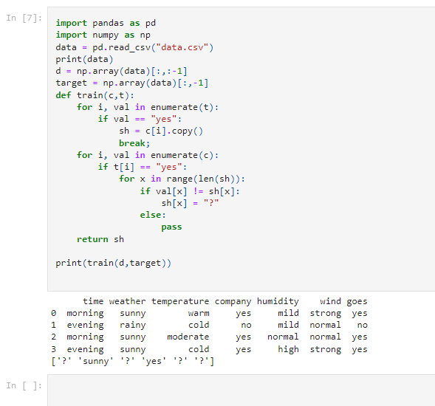

**2.For a given set of training data examples stored in a .CSV file, implement and demonstrate the Candidate-Elimination algorithm to output a description of the set of all hypotheses consistent with the training examples.**

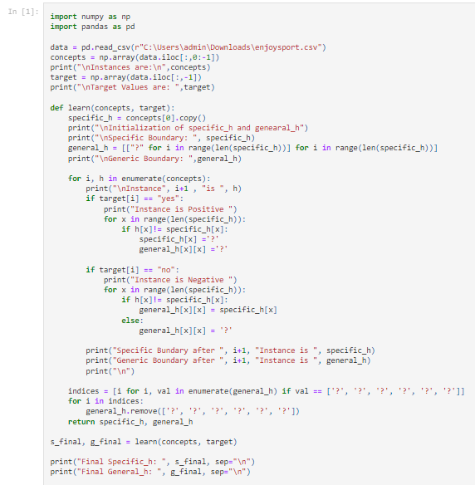

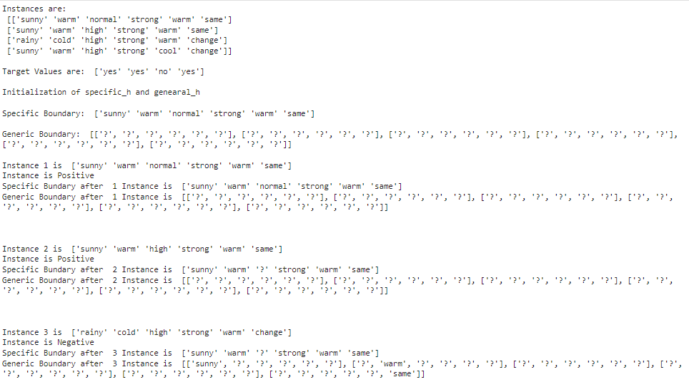

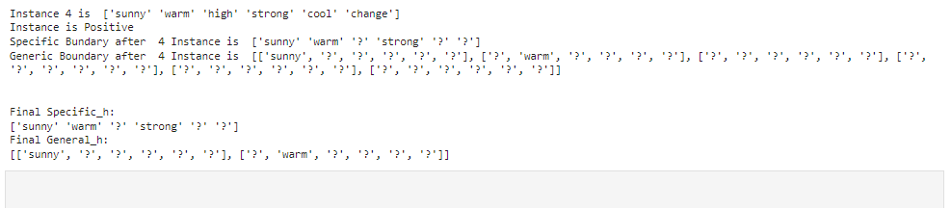

**3.Write a program to demonstrate the working of the decision tree based ID3 algorithm. Use an appropriate data set for building the decision tree and apply this knowledge to classify a new sample**

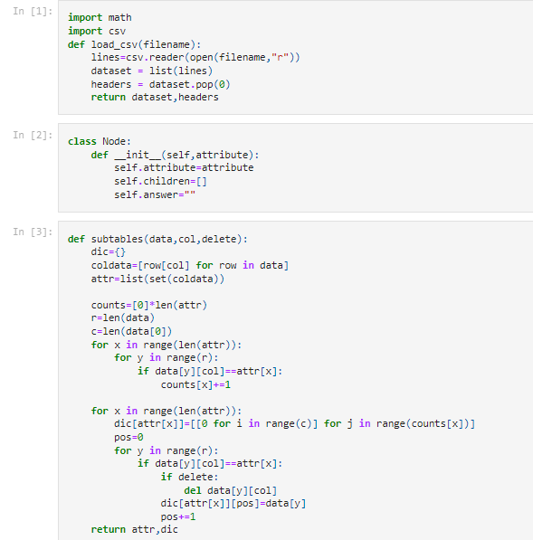

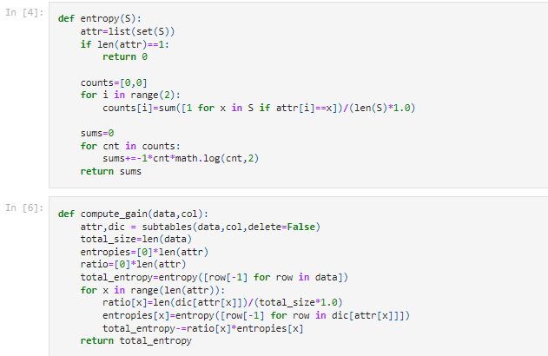

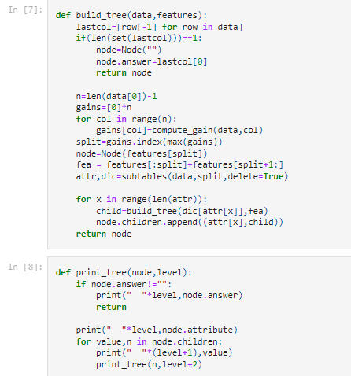

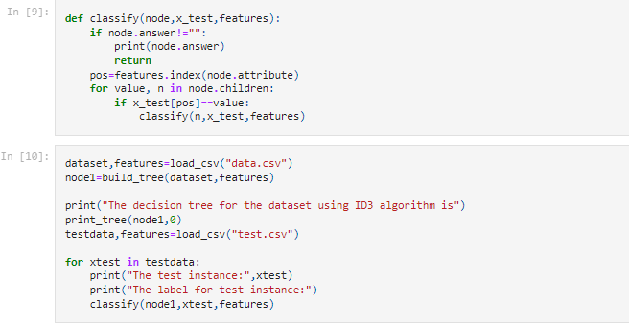

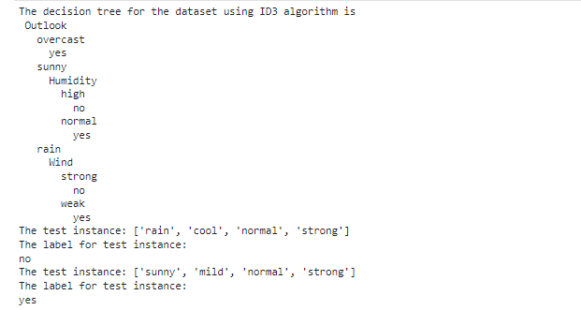

**4.Write a program to implement the naive Bayesian classifier for a sample training data set stored as a .CSV file. Compute the accuracy of the classifier, considering few test data samples**

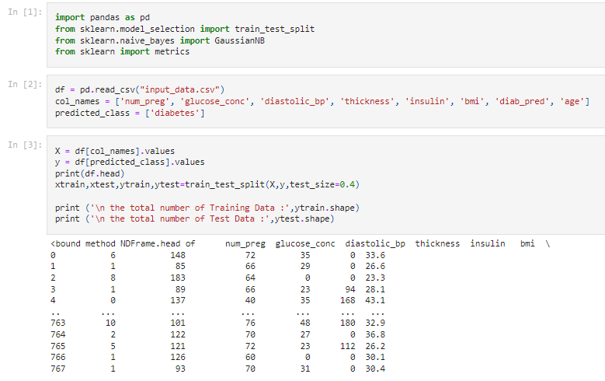

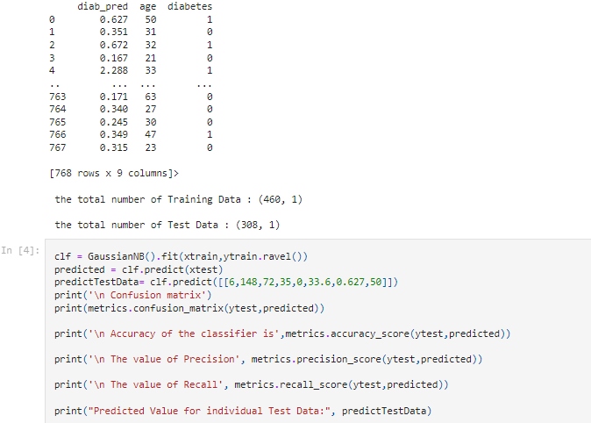

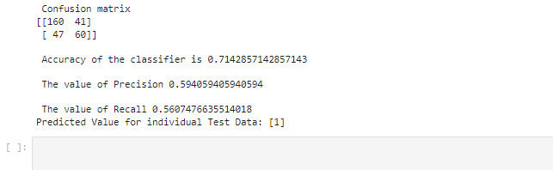

**5.Implement the Linear Regression algorithm in order to fit data points. Select appropriate data set for your experiment and draw graphs.**

